Static Website Hosting with S3

1. Create a S3 bucket and import (HTML, CSS, JS) file that has been saved in our desktop.

index.html-------------------------(1)

<!DOCTYPE html>

<html lang="en">

<head>

<meta charset="UTF-8">

<meta name="viewport" content="width=device-width, initial-scale=1.0">

<title>My Static Website</title>

<link rel="stylesheet" href="styles.css">

</head>

<body>

<h1>Welcome to My Static Website</h1>

<p>This is a simple static website hosted on Amazon S3.</p>

<button onclick="displayMessage()">Click Me!</button>

<script src="script.js"></script>

</body>

</html>

-----------------------------------------------------------------------------------------------------------------------------------

Styles.css----------------------------------(2)

body {

font-family: Arial, sans-serif;

background-color: #f0f0f0;

text-align: center;

padding: 50px;

}

h1 {

color: #333;

}

button {

background-color: #4CAF50;

color: white;

padding: 10px 20px;

border: none;

cursor: pointer;

}

button:hover {

background-color: #45a049;

}

----------------------------------------------------

script.js--------------------------------(3)

function displayMessage() {

alert("Hello, welcome to my website hosted on S3!");

}

1. Place this 2 files (styles.css, script.js) in a single folder and html has be alone.

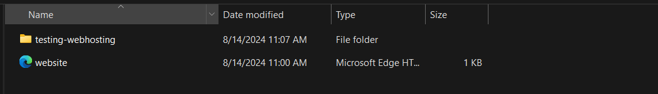

Then,

Upload this folder and file in S3 bucket,

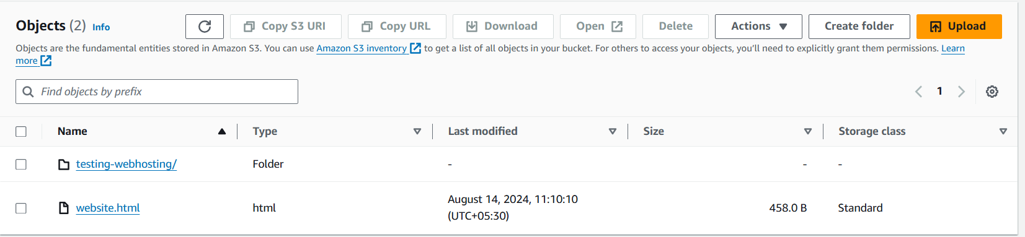

**In “properties”** Config the “**Static website hosting”**

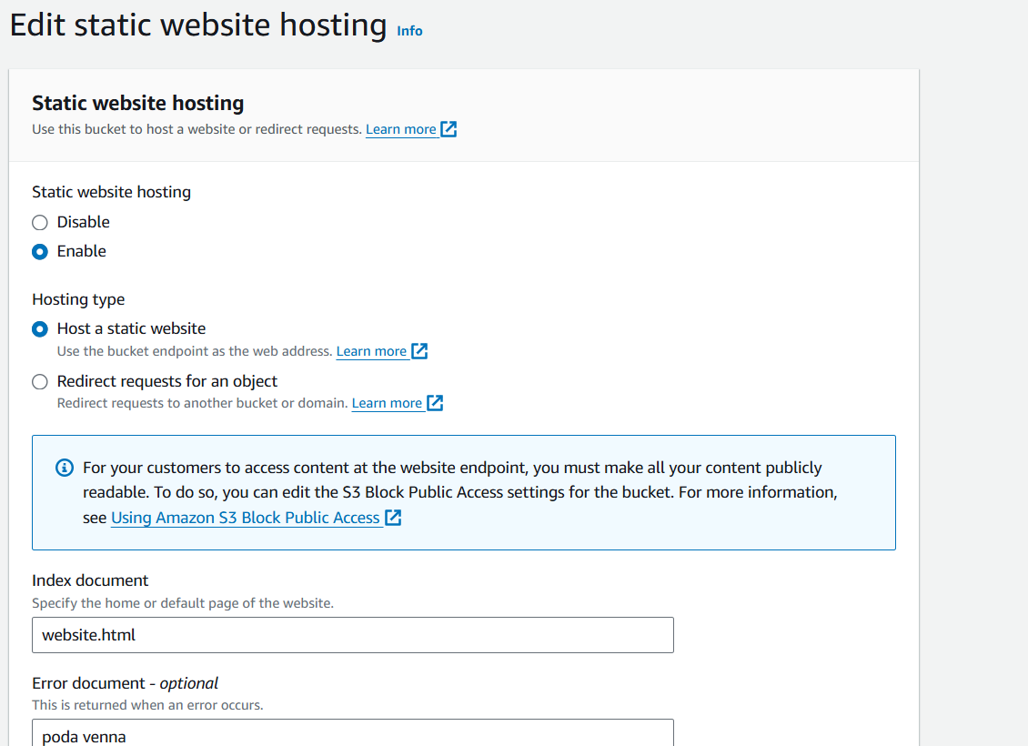

**Then save it……………………..**

**Click “Permissions”**

**and enable Block public access (bucket settings) and Object Ownership---**

1. **Enable ACLs Enabled – it gives access to public  
   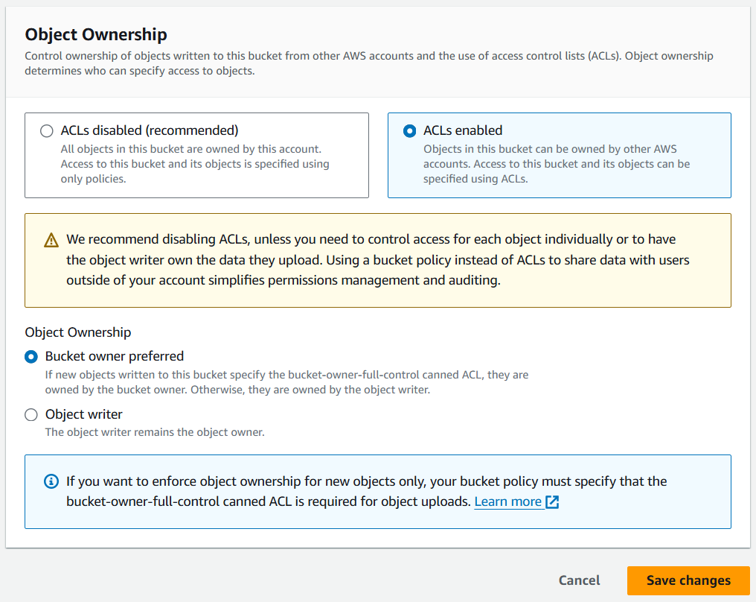**

Then go to “objects” and select both file and folder and click “actions”, then scroll down and “make public using ACL”

Or,

Put this command in the “bucket policy”

{

"Version": "2012-10-17",

"Statement": [

{

"Sid": "PublicReadGetObject",

"Effect": "Allow",

"Principal": "*",

"Action": "s3:GetObject",

"Resource": "arn:aws:s3:::your-bucket-name/*"

}

]

}

-----------------------------------------------------